Given the root of a binary tree and an integer targetSum, return *the number of paths where the sum of the values along the path equals* targetSum.

The path does not need to start or end at the root or a leaf, but it must go downwards (i.e., traveling only from parent nodes to child nodes).

**Example 1:**

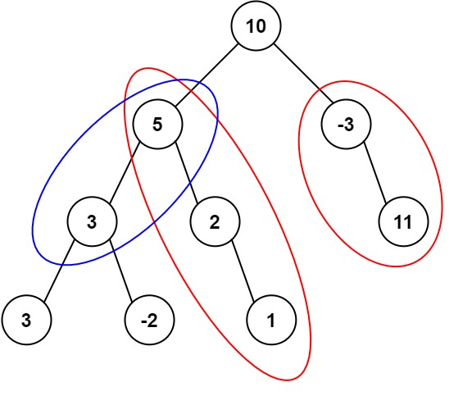

Input: root = [10,5,-3,3,2,null,11,3,-2,null,1], targetSum = 8  
Output: 3  
Explanation: The paths that sum to 8 are shown.

**Example 2:**

Input: root = [5,4,8,11,null,13,4,7,2,null,null,5,1], targetSum = 22  
Output: 3

**Constraints:**

* The number of nodes in the tree is in the range [0, 1000].
* -109 <= Node.val <= 109
* -1000 <= targetSum <= 1000